Guide to Hacking with sub7
By Ølîprõ
Customising your trojan:

- Well first you need a victim so ICQ would be a brilliant place to start, considering you can get a program that’ll give you that victim’s I.P if you can’t get the scanner on sub7 to work. However they need to be on your list to get their I.P a good program would be wonder ICQ me get it at http://www.8th-wonder.com after you’ve logged their I.P you need to customise your virus:
- 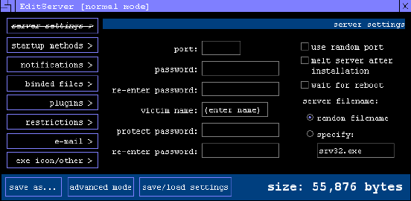Here is a screen shot f edit server 1st screen:
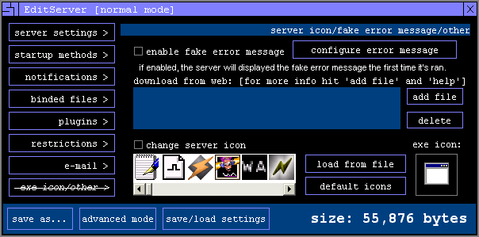
In the port field choose a number between 0001 – 9999 (just for ease of memory) and note that, then give the victim a name. Enter a protect password if you don’t want anyone else to be able to hack them don’t enter a password in the 3rd box because the victim will have to enter a password to let the virus work oh and give the server a innocent sounding filename like win update. Now to start-up methods: This is quite easy: just select 1 or more start-up methods (choose all if you want it difficult to remove here.) Now onto notifications: get an ICQ account and get it to tell you like that it is most reliable and gives u their I.P too which means you don’t need to get their I.P via a tool but I prefer to in case the notify doesn’t work. Now binded files: this just lets you make files get run or extracted (to make it look genuine so if you said it’s a pic then add a pic (you get the idea.)) Plugins is just the .dll files you integrate with server so you can play with their PC (they’ll be in the folder you extracted sub7 to) I recommend fun1 and 2 plus advanced and ICQpwsteal (all of them if you think the victim won’t get suspicious of the size.) I won’t bother with restrictions because that’s just to limit your fun so leave that alone… e-mail let’s you be notified of the victims keypresses via e-mail (and passwords that is recorded and aim, msn & ICQ etc…) now the final touches:
If you didn’t put any files in with it the fake error message is perfect (don’t forget to configure it) I recommend you don’t bother with download from web. Put a tick in change server icon (make sure it matches with what the victim thinks they’re downloading then you’re done! Now just click save as… (put it somewhere you can remember) and name it (something like pics and don’t forget to put .exe after it E.G.: if you call it pics type pics.exe) geddit?
Hacking the Victim
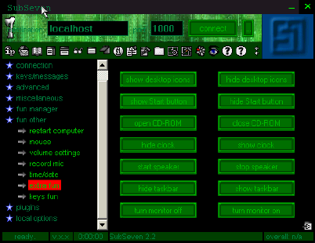
Now the fun part get yourself a victim one without an anti-virus (or one stupid enough to believe that they need to disable it make up something like “it’s a self-extracting exe disable ur anti-virus or it’ll corrupt your.dll files”). After the victim has downloaded and run the file you should get a notification (if you enabled the function) so if you haven’t already got their I.P you will now! Now load sub7 and enter their I.P and the port number (I hope you remembered!) if you gave a protect password you’ll be asked to enter that. Now the fun begins: if you want to be malicious then I’m going to leave that for you to discover but here’s a screenshot for the fun stuff:

As you can – can’t see you can open & close their cd-rom, start & stop an annoying beep on the system speakers let’s just say there’s loads of stuff! I suggest getting zonealarm form http://www.zonelabs.com and infecting yourself, eventually zonealarm will detect it and ask you if you want to give the virus server capabilities, which you say no. Then go into the program & find the virus and give it only local server abilities to connect to yourself you don’t need to be on the internet just put the correct port number for the virus and put localhost and click connect and have fun with yourself!!! May I recommend the realistic matrix program on sub7 btw

Well that’s all from me! Happy H@çkîñg and check out my website http://www.pro-hacking.com (will be online soon)

